

# Task 2 – Credit Submission

Student Number: 104071453  
Student Name: Marco Giacoppo

### Credit 2a

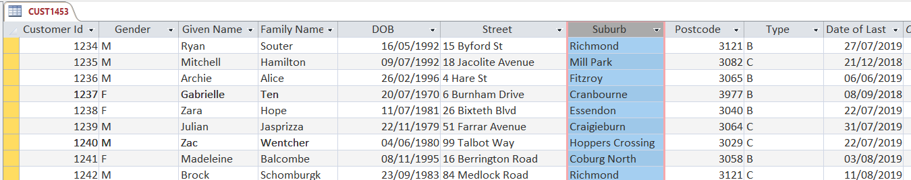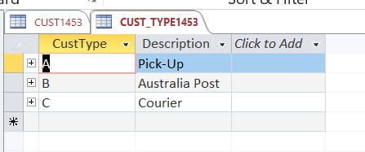

### Credit 2b

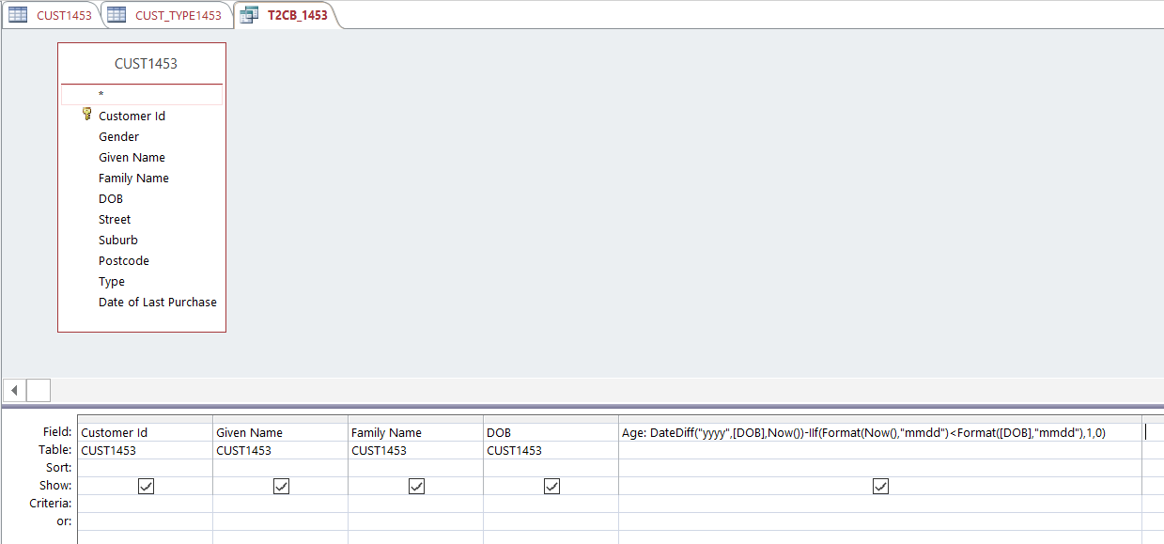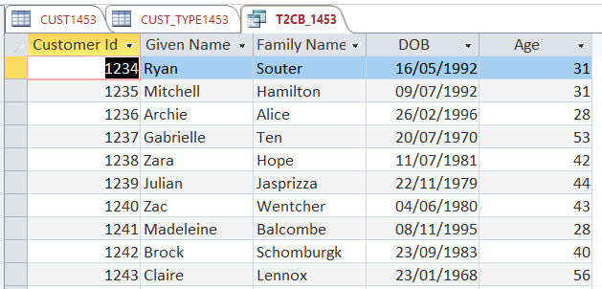

### Credit 2c

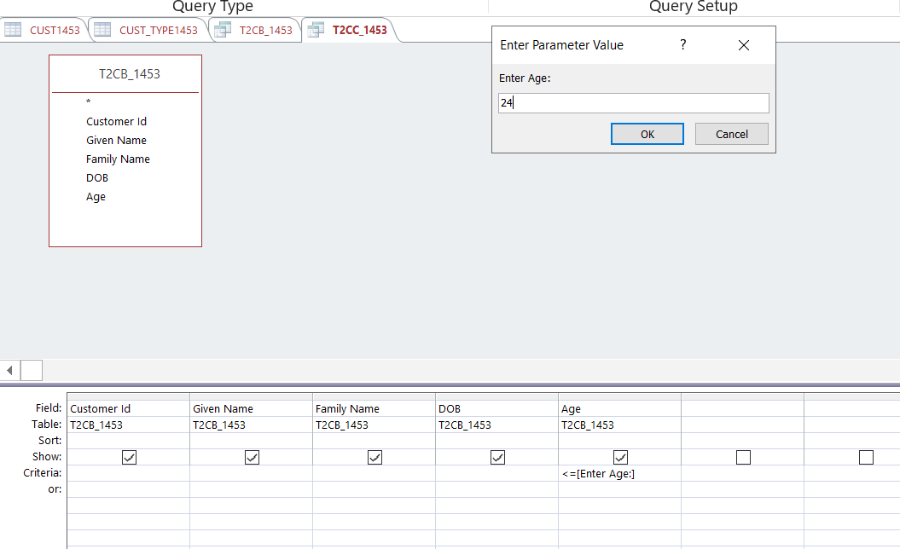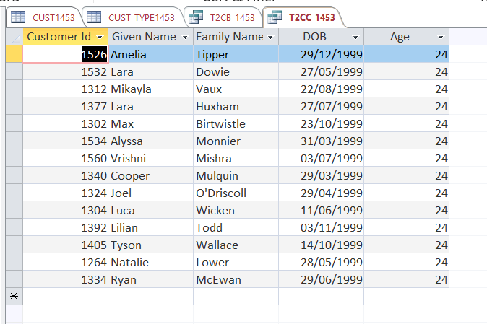

### Credit 2d

### Credit 2e

### Credit 2f

### Credit 2g

### Credit 2h

### Credit 2i

### Credit 2j

